**CHAPTER 1**

**INTRODUCTION**

* 1. **GENERAL**

In the rapidly evolving landscape of retail, Artificial Intelligence (AI) has emerged as a transformative force, reshaping how businesses operate and interact with customers. This project, "AI-Enhanced Shopping Experience," aims to leverage AI technologies to create a more personalized, efficient, and engaging shopping journey for consumers. By integrating advanced AI algorithms, this project seeks to address key challenges faced by retailers, such as enhancing customer satisfaction, optimizing inventory management, and improving sales performance.

The project's core focus is on developing intelligent systems that can provide personalized recommendations, streamline customer support through AI-powered chatbots, and enhance the shopping experience with features like visual search and augmented reality. Additionally, the project will incorporate predictive analytics to anticipate consumer needs, dynamic pricing strategies to maximize profitability, and robust fraud detection mechanisms to ensure secure transactions.

Through the integration of these AI-driven solutions, this project aims to not only improve the operational efficiency of retail businesses but also to deliver a seamless and enjoyable shopping experience for consumers. By harnessing the power of AI, retailers can gain deeper insights into customer behavior, adapt to market trends more swiftly, and ultimately drive greater value for both businesses and their customers.

This project, "AI-Enhanced Shopping Experience," focuses on harnessing the power of artificial intelligence to revolutionize the retail sector. By implementing features such as personalized recommendations, AI-driven chatbots, and predictive analytics, the project aims to enhance customer satisfaction and streamline retail operations. With additional innovations like dynamic pricing, fraud detection, and augmented reality, this project seeks to create a seamless, secure, and engaging shopping experience, ultimately driving better outcomes for both consumers and retailers.

* 1. **NEED FOR THE STUDY**

The retail industry is undergoing a significant transformation driven by changing consumer expectations and technological advancements. Traditional shopping methods often fall short in delivering the personalized, efficient, and secure experiences that modern consumers demand. The need for this study arises from the growing importance of leveraging AI technologies to address these challenges.

By understanding and implementing AI-driven solutions, retailers can offer personalized recommendations, enhance customer support, optimize inventory, and prevent fraud. This study is essential to explore how AI can improve operational efficiency, increase customer satisfaction, and drive sales growth. Additionally, it aims to identify the best practices and strategies for integrating AI into the retail environment, ensuring businesses remain competitive in an increasingly digital marketplace.

The rapid evolution of consumer behavior, coupled with the increasing complexity of the retail landscape, underscores the necessity of adopting advanced technological solutions like artificial intelligence. Traditional retail models often struggle to keep up with the demands for personalization, real-time assistance, and seamless shopping experiences across multiple channels. This creates a pressing need to study and implement AI-driven innovations that can bridge these gaps.

AI technologies offer transformative potential by enabling retailers to analyze vast amounts of customer data, predict trends, and make data-driven decisions. Personalized recommendations based on individual preferences can significantly enhance customer satisfaction and loyalty. Additionally, AI-powered tools such as chatbots, visual search, and dynamic pricing not only streamline operations but also elevate the overall shopping experience.

Furthermore, with the rise of e-commerce, issues like fraud detection and efficient inventory management have become critical. AI can provide robust solutions to these challenges, ensuring secure transactions and optimal stock levels. The study also addresses the need for businesses to stay competitive in a market where consumer expectations are continually rising. By embracing AI, retailers can enhance their agility, respond to market trends more swiftly, and deliver superior value to customers.

**1.3 OBJECTIVES OF THE STUDY**

• **To Explore AI Applications in Retail**:

Identify and analyze the various AI technologies and their applications in enhancing the shopping experience, including personalized recommendations, chatbots, visual search, and dynamic pricing.

• **To Improve Customer Engagement**:

Develop and implement AI-driven solutions that enhance customer satisfaction through personalized and seamless shopping experiences.

• **To Optimize Operational Efficiency**:

Investigate how AI can streamline retail operations, such as inventory management, demand forecasting, and dynamic pricing strategies, to improve efficiency and reduce costs.

•**To Enhance Security and Fraud Detection**:

Implement AI-based fraud detection mechanisms to ensure secure transactions and protect both retailers and customers from fraudulent activities.

•**To Analyze Consumer Behavior**:

Utilize AI analytics to gain insights into consumer preferences and behavior, enabling data-driven decision-making for better product recommendations and marketing strategies.

•**To Assess the Impact on Business Performance**:

Measure the impact of AI integration on key business metrics such as sales growth, customer retention, and operational efficiency.

•**To Explore Future Trends in AI for Retail**:

Investigate emerging AI trends and technologies that could further transform the retail sector and provide a competitive advantage.

•**To Provide a Framework for AI Adoption**:

Develop a comprehensive framework or set of best practices for retailers to effectively adopt and integrate AI technologies into their business models.

* 1. **OVERVIEW OF THE PROJECT**

The "AI-Enhanced Shopping Experience" project encompasses a wide range of AI applications designed to transform various aspects of the retail industry. Key points include:

1. **Personalized Customer Journeys**:

Leveraging machine learning algorithms to analyze customer data and behavior, the project aims to deliver highly personalized shopping experiences, from product recommendations to targeted marketing campaigns.

1. **Enhanced Customer Support**:

AI-driven chatbots and virtual assistants will be integrated to provide 24/7 customer service, handling inquiries, guiding users through the purchase process, and offering post-purchase support.

1. **Visual Search and AR Integration**:

The project will include visual search functionality, enabling users to search for products using images. Augmented reality (AR) features will allow customers to virtually try on products such as clothing, accessories, or cosmetics.

1. **Dynamic and Predictive Pricing**:

Utilizing AI algorithms to dynamically adjust pricing based on real-time market conditions, competitor pricing, and consumer demand, the project aims to maximize sales and profitability.

1. **Inventory Optimization**:

AI-powered inventory management systems will forecast demand, reduce overstock and understock situations, and ensure optimal stock levels, minimizing costs and improving supply chain efficiency.

1. **Fraud Detection and Security**:

Advanced AI models will be employed to detect and prevent fraudulent activities, enhancing transaction security and protecting customer data.

**WORKFLOW**

1. **Problem Definition and Requirement Analysis**

Identify challenges in the retail sector and define project goals.

* + Gather requirements from stakeholders (retailers, consumers).

1. **Data Collection and Preprocessing**
   * Collect relevant data (customer purchase history, browsing behavior, product details).
   * Clean and preprocess data for AI model training and analysis.
2. **Model Selection and Development**
   * Choose appropriate AI models (e.g., recommendation systems, NLP for chatbots, computer vision for visual search).
   * Develop and train models using collected data.
3. **Implementation of AI Features**
   * Integrate personalized recommendation engines into the shopping platform.
   * Deploy AI chatbots for customer support.
   * Implement visual search and augmented reality features.
4. **Operational Efficiency Enhancements**
   * Develop inventory management models for demand forecasting.
   * Implement dynamic pricing algorithms.
5. **Security and Fraud Detection**
   * Build and integrate fraud detection systems to secure transactions.
6. **User Interface Design and Integration**
   * Design a user-friendly interface for seamless interaction with AI features.
   * Ensure cross-channel integration for consistency across web, mobile, and in-store experiences.
7. **Testing and Validation**
   * Conduct extensive testing of AI models and integrated systems.
   * Validate performance, accuracy, and user experience.
8. **Deployment and Monitoring**
   * Deploy the AI-driven solutions in a live retail environment.
   * Continuously monitor system performance and user feedback.

10. **Documentation and Knowledge Sharing**

* Document the development process, AI models, and system architecture.
* Share findings and best practices with stakeholders.

**CHAPTER 2**

**REVIEW OF LITERATURE**

**2.1 INTRODUCTION**

The integration of artificial intelligence (AI) in the retail sector has been the subject of extensive research, highlighting its transformative impact on enhancing customer experiences and improving operational efficiencies. This review of literature aims to explore the existing body of work on AI applications in retail, providing a comprehensive understanding of the advancements, methodologies, and outcomes documented in previous studies.

**1. The Evolution of AI in Retail**The literature reveals a historical perspective on the adoption of AI technologies in retail, tracing their evolution from basic automation processes to advanced machine learning algorithms that power sophisticated applications. Early research focused on operational efficiencies, while recent studies emphasize customer-centric solutions that enhance engagement and satisfaction.

**2. Personalized Shopping Experiences**Numerous studies have demonstrated the effectiveness of AI-driven personalized recommendation systems in increasing customer engagement and sales. Research has shown that tailored product suggestions based on user behavior significantly improve the shopping experience, leading to higher conversion rates and customer loyalty.

**3. AI-Powered Customer Support**The implementation of chatbots and virtual assistants has been a focal point in the literature, with studies highlighting their role in providing real-time customer support. Research indicates that AI-driven customer service solutions can reduce response times and improve customer satisfaction by handling routine inquiries and assisting with purchases.

**4. Visual Search and Augmented Reality**Literature on visual search technology and augmented reality (AR) applications in retail illustrates their potential to enhance the shopping experience. Studies have shown that allowing customers to search for products using images and try items virtually can significantly influence purchase decisions and increase consumer confidence.

**5. Operational Efficiency and Inventory Management**Research has explored the role of AI in optimizing inventory management and demand forecasting. Studies suggest that AI algorithms can analyze historical sales data and market trends, leading to more accurate demand predictions and better inventory control, which reduces costs and improves service levels.

**2.2 LITERATURE REVIEW**

|  |  |  |  |  |  |
| --- | --- | --- | --- | --- | --- |
| **S.**  **No** | **Author**  **Name** | **Paper**  **Title** | **Description** | **Journal** | **Year** |
| 1. | Kumar, A., Singh, S., & Kumar, A. | A Review on Artificial Intelligence Techniques in Retail Sector | Overview of various AI techniques used to enhance customer experiences and operational efficiency in retail. | International Journal of Computer Applications | 2018 |
| 2. | Gnewuch, U., Morana, S., & Maedche, A. | Designing Chatbot Services: A Service-Dominant Logic Perspective | Discussion on chatbot design and its role in improving customer service in retail environments. | Proceedings of the 39th International Conference on Information Systems (ICIS) | 2018 |
| 3. | Hu, Y., Zhang, Z., & Liu, X. | Visual Search in E-commerce: A Survey | Review of visual search technologies and their impact on e-commerceuser experiences. | IEEE Transactions on Multimedia | 2019 |
| 4. | Zheng, L., Zhang, Y., & Zheng, Z. | The Impact of Online Customer Reviews on Purchasing Decisions: The Moderating Role of Product Type | Analysis of how online reviews affect purchasing decisions in retail, with insights for retailers. | International Journal of Information Management | 2020 |

**Table no 1 Literature Review**

**CHAPTER 3**

**SYSTEM OVERVIEW**

**3.1 EXISTING SYSTEM**

In the current retail landscape, many businesses are still heavily reliant on traditional methods for managing customer interactions and inventory. Retailers often utilize static promotional strategies, generic marketing techniques, and manual inventory management systems that lack real-time data insights. Customers typically experience a one-size-fits-all approach, where product recommendations are not personalized, leading to a suboptimal shopping experience. For instance, many e-commerce platforms display products based on past sales data rather than tailoring suggestions based on individual customer preferences and browsing history.

Additionally, customer support in many retail environments often relies on human representatives, which can result in longer wait times and inconsistent service quality. Retailers face challenges in responding quickly to customer inquiries and providing instant assistance, leading to potential dissatisfaction and lost sales opportunities. The lack of automation in customer service means that businesses cannot efficiently handle high volumes of inquiries, especially during peak shopping times.

Inventory management practices frequently depend on manual tracking and periodic stock assessments. This can lead to inefficiencies such as overstocking or stockouts, impacting sales and customer satisfaction. Retailers may not have accurate insights into inventory levels in real time, making it difficult to forecast demand accurately and respond to changing market conditions. As a result, many retailers struggle to optimize their supply chains and reduce operational costs.

**3.2 PROPOSED SYSTEM**

The proposed system for the AI-Enhanced Shopping Experience integrates advanced artificial intelligence technologies to revolutionize the retail environment. This system aims to create a seamless, personalized shopping journey for consumers, leveraging machine learning algorithms and data analytics to understand and anticipate customer needs. By harnessing real-time data from user interactions, purchase history, and preferences, the system will provide tailored product recommendations, ensuring that shoppers receive suggestions that resonate with their individual tastes and buying patterns.

In addition to personalized recommendations, the proposed system incorporates AI-powered chatbots and virtual assistants to enhance customer service. These chatbots will be available 24/7 to address customer inquiries, assist with product searches, and guide users through the purchasing process. By providing instant support and assistance, the system will improve customer satisfaction and reduce the burden on human customer service representatives, allowing them to focus on more complex issues that require personal attention.

The system will also implement visual search technology, enabling customers to search for products using images rather than text. This feature will simplify the shopping process by allowing users to upload photos of items they are interested in, thereby receiving accurate search results quickly. Coupled with augmented reality capabilities, customers will have the option to virtually try on clothing or visualize furniture in their homes before making a purchase, enhancing their confidence in their buying decisions.

To optimize inventory management, the proposed system will employ predictive analytics to forecast demand and manage stock levels efficiently. By analyzing historical sales data and market trends, the system can recommend optimal inventory levels, reducing the risks of overstocking or stockouts. This proactive approach will not only enhance operational efficiency but also ensure that popular products are always available for customers.

**3.3 FEASIBILITY STUDY**

The feasibility study for the event management system examines three main aspects: operational feasibility, financial feasibility, and technical feasibility.

A series of factors are evaluated to determine whether or not development and implementation of the proposed system are viable and practical.

1. Technical Feasibility: The technical feasibility of the project focuses on the availability and integration of AI technologies, such as machine learning algorithms, natural language processing, and augmented reality. The required infrastructure, including data storage capabilities, cloud computing resources, and integration with existing retail systems, will be examined. Additionally, the project will leverage readily available AI tools and frameworks, which are widely supported by vendors and open-source communities, ensuring the technology's accessibility and scalability for retail applications.
2. Operational Feasibility: Operational feasibility assesses the impact of AI integration on current retail operations and customer service practices. This involves evaluating the potential changes in workflows, staff training needs, and customer interactions. Implementing AI-driven solutions, such as chatbots and personalized recommendation systems, can enhance customer experiences and free up human resources for more complex tasks. The study will also explore the potential for increased efficiency in inventory management and data analysis, which can lead to better-informed business decisions and improved customer satisfaction.
3. Financial Feasibility: The financial feasibility of the project considers the initial investment required for technology acquisition, development, and implementation, as well as the ongoing operational costs. A cost-benefit analysis will be conducted to assess the expected return on investment (ROI) through increased sales, reduced operational costs, and improved customer retention. Additionally, the study will evaluate potential funding sources, such as grants or partnerships with technology providers, to support the project's financial sustainability.

**CHAPTER 4**

**SYSTEM REQUIREMENTS**

**4.1 SOFTWARE REQUIREMENTS**

**1. AI and Machine Learning Frameworks**

* **TensorFlow**: For developing machine learning models, particularly for recommendation systems and natural language processing tasks.
* **PyTorch**: An alternative to TensorFlow, suitable for building and training neural networks for various AI applications.
* **scikit-learn**: For implementing machine learning algorithms and data preprocessing tasks.

**2. Natural Language Processing (NLP) Libraries**

* **NLTK (Natural Language Toolkit)**: For basic NLP tasks such as tokenization, stemming, and sentiment analysis.
* **spaCy**: For advanced NLP capabilities, including named entity recognition and dependency parsing.
* **Transformers (by Hugging Face)**: For implementing state-of-the-art transformer models for NLP tasks.

**3. Web Development Frameworks**

* **Django**: A high-level Python web framework for building the backend of the e-commerce platform, handling requests, and serving AI functionalities.
* **Flask**: A lightweight alternative to Django for creating web applications with API support.

**4. Frontend Technologies**

* **React.js or Angular**: For building interactive and responsive user interfaces that enhance customer experience.
* **HTML/CSS**: For basic web page structure and styling.
* **JavaScript**: For dynamic client-side scripting and enhancing user interactions.

**5. Database Management Systems**

* **PostgreSQL or MySQL**: Relational database management systems for storing user data, product information, and transaction records.
* **MongoDB**: A NoSQL database option for handling unstructured data, such as user reviews and product metadata.

**6. Cloud Computing Services**

* **Amazon Web Services (AWS) or Microsoft Azure**: For scalable cloud hosting, data storage, and machine learning model deployment.
* **Google Cloud Platform (GCP)**: An alternative for cloud computing needs, particularly for AI and big data analytics services.

**7. Data Visualization Tools**

* **Tableau or Power BI**: For creating interactive dashboards and visualizing data insights for decision-making.
* **Matplotlib and Seaborn**: Python libraries for generating static and interactive plots.

**8. Version Control and Collaboration Tools**

* **Git**: For version control and collaboration on code development.
* **GitHub or GitLab**: Platforms for hosting code repositories and facilitating team collaboration.

**9. Testing and Debugging Tools**

* **Selenium**: For automated testing of web applications to ensure functionality and performance.
* **Jest or Mocha**: JavaScript testing frameworks for unit testing and integration testing of frontend applications.

**10. Security Tools**

* **OWASP ZAP (Zed Attack Proxy)**: For security testing and vulnerability scanning of web applications.
* **SSL Certificates**: To secure data transmission and protect user information during transactions.

**4.2 HARDWARE REQUIREMENTS**

**Processing Unit**:

* High-performance processors like Intel i7/i9 or AMD Ryzen 7/9 for efficient handling of computational tasks.
* GPUs such as NVIDIA RTX 3000 series or above for AI model training and inference, particularly for visual search and deep learning applications.

**Memory**:

* Minimum 16GB RAM to support multitasking and efficient data processing.
* Expandable to 32GB or higher for larger datasets and more complex operations.

**Storage**:

* Solid-State Drives (SSD) with at least 1TB capacity for faster data access and model storage.
* Additional external or cloud storage for backup and large datasets.

**Networking**:

* High-speed internet connectivity with a minimum bandwidth of 100 Mbps for smooth data transmission and cloud integration.
* Dedicated servers with robust firewalls for secure data communication.

**Peripherals**:

* High-resolution displays for development and testing.
* Input devices such as keyboard and mouse for operational tasks.
* Backup power supplies (UPS) to ensure uninterrupted system operations.

**4.3 FUNCTIONAL REQUIREMENTS**

**Personalized Recommendations**:

* Provide product suggestions tailored to individual user preferences and past behaviors.

**AI-Driven Chatbot**:

* Respond to customer inquiries in real time, assist with product selection, and handle common support issues.

**Visual Search**:

* Allow users to search for products by uploading images, leveraging computer vision technologies.

**Dynamic Pricing**:

* Adjust product prices based on market trends, competition, and user demand in real time.

**Fraud Detection**:

* Identify and prevent unauthorized or fraudulent activities during transactions.

**Inventory Management**:

* Predict product demand and optimize stock levels using AI algorithms.

**Seamless User Interface**:

* Enable intuitive navigation and interaction across web and mobile platforms.

**Analytics Dashboard**:

* Generate comprehensive reports on user behavior, sales, and operational metrics.

**4.4 NON-FUNCTIONAL REQUIREMENTS**

**Scalability**:

* Support a growing number of users and products without performance degradation.

**Performance**:

* Ensure quick response times for queries, recommendations, and transactions, maintaining a latency of less than 2 seconds.

**Security**:

* Protect user data with encryption and secure protocols, adhering to GDPR and other data protection standards.

**Usability**:

* Offer a user-friendly interface with minimal learning curve and clear navigation.

**Availability**:

* Guarantee 99.9% uptime for uninterrupted access to features and services.

**Maintainability**:

* Ensure the system can be easily updated and maintained with modular architecture and clear documentation.

**Compatibility**:

* Ensure the system is compatible with different devices, browsers, and operating systems.

**Reliability**:

* Prevent system crashes and recover swiftly from unexpected failures to ensure a stable user experience.

**CHAPTER 5**

**SYSTEM DESIGN**

* 1. **SYSTEM ARCHITECTURE**

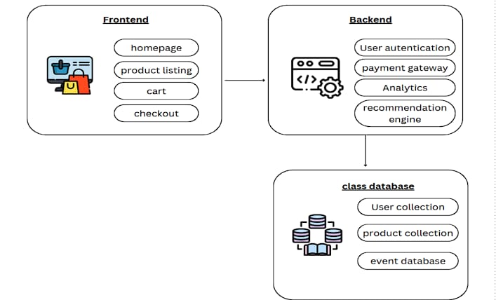

Fig1

The frontend is the user-facing part of the website. It consists of:

* **Homepage:** The main landing page, often showcasing featured products or promotions.
* **Product Listing:** Displays a list of available products, allowing users to search, filter, and sort.
* **Cart:** Where users add items they want to purchase and view their current order.
* **Checkout:** The final stage of the purchase process, where users provide shipping and payment information.

**Backend**

The backend handles the server-side logic and data processing. It includes:

* **User Authentication:** Handles user logins and registration, ensuring secure access to accounts.
* **Payment Gateway:** Integrates with payment processors to facilitate secure transactions.
* **Analytics:** Collects and processes data on user behavior, product performance, and website traffic.
* **Recommendation Engine:** Uses machine learning algorithms to suggest products based on user preferences and purchase history.

**Database**

The database stores all the website's data. It consists of:

* **User Collection:** Stores information about registered users, including personal details, purchase history, and preferences.
* **Product Collection:** Contains details about all products available on the website, such as descriptions, prices, and images.
* **Event Database:** Logs user interactions and system events, used for analytics and troubleshooting.

**Data Flow**

1. **User Interaction:** A user interacts with the frontend components (e.g., clicks on a product, adds to cart, proceeds to checkout).
2. **Frontend Request:** The frontend sends requests to the backend for data retrieval or action execution.
3. **Backend Processing:** The backend handles the request, interacts with the database to fetch or store data, and performs necessary processing (e.g., authenticating users, processing payments, generating recommendations).
4. **Response to Frontend:** The backend sends a response to the frontend, which is then displayed to the user.

**Additional Considerations**

* **Security:** Implementing robust security measures is crucial to protect user data and prevent unauthorized access.
* **Scalability:** The architecture should be designed to handle increasing traffic and data volume as the website grows.
* **Performance:** Optimizing database queries, caching frequently accessed data, and using efficient algorithms can improve website performance.

By understanding these components and their interactions, you can build a robust and scalable e-commerce platform.

**CHAPTER-6**

**PROGRAM CODE**

**Backend**:

// backend/config/db.js

const mongoose = require('mongoose');

const connectDB = async () => {

try {

await mongoose.connect(process.env.MONGO_URI, { useNewUrlParser: true, useUnifiedTopology: true });

console.log("MongoDB connected");

} catch (error) {

console.error("Database connection failed:", error);

process.exit(1);

}

};

module.exports = connectDB;

// backend/models/User.js

const mongoose = require('mongoose');

const userSchema = new mongoose.Schema({

username: { type: String, required: true, unique: true },

password: { type: String, required: true },

role: { type: String, default: "user" }

});

module.exports = mongoose.model('User', userSchema);

/ backend/models/Product.js

const mongoose = require('mongoose');

const productSchema = new mongoose.Schema({

name: { type: String, required: true },

description: { type: String },

price: { type: Number, required: true },

category: { type: String, enum: ['Food', 'Clothing'], required: true },

stock: { type: Number, default: 0 }

});

module.exports = mongoose.model('Product', productSchema);

// backend/models/Order.js

const mongoose = require('mongoose');

const orderSchema = new mongoose.Schema({

userId: { type: mongoose.Schema.Types.ObjectId, ref: 'User', required: true },

products: [{

productId: { type: mongoose.Schema.Types.ObjectId, ref: 'Product' },

quantity: { type: Number, default: 1 }

}],

status: { type: String, default: 'Pending' },

totalAmount: { type: Number, required: true }

});

module.exports = mongoose.model('Order', orderSchema);

// backend/models/Order.js

const mongoose = require('mongoose');

const orderSchema = new mongoose.Schema({

userId: { type: mongoose.Schema.Types.ObjectId, ref: 'User', required: true },

products: [{

productId: { type: mongoose.Schema.Types.ObjectId, ref: 'Product' },

quantity: { type: Number, default: 1 }

}],

status: { type: String, default: 'Pending' },

totalAmount: { type: Number, required: true }

});

module.exports = mongoose.model('Order', orderSchema);

// backend/controllers/authController.js

const User = require('../models/User');

const bcrypt = require('bcryptjs');

const jwt = require('jsonwebtoken');

exports.register = async (req, res) => {

const { username, password } = req.body;

const hashedPassword = await bcrypt.hash(password, 10);

const user = new User({ username, password: hashedPassword });

try {

await user.save();

res.status(201).json({ message: 'User registered' });

} catch (error) {

res.status(400).json({ error: 'Registration failed' });

}

};

exports.login = async (req, res) => {

const { username, password } = req.body;

const user = await User.findOne({ username });

if (user && (await bcrypt.compare(password, user.password))) {

const token = jwt.sign({ id: user._id, role: user.role }, process.env.JWT_SECRET);

res.json({ token });

} else {

res.status(401).json({ error: 'Invalid credentials' });

    }

};

// backend/controllers/productController.js

const Product = require('../models/Product');

exports.createProduct = async (req, res) => {

const { name, description, price, category, stock } = req.body;

const product = new Product({ name, description, price, category, stock });

try {

await product.save();

res.status(201).json(product);

} catch (error) {

res.status(400).json({ error: 'Error creating product' });

}

};

exports.getProducts = async (req, res) => {

try {

const products = await Product.find();

res.json(products);

} catch (error) {

res.status(400).json({ error: 'Error fetching products' });

    }

};

// backend/routes/authRoutes.js

const express = require('express');

const { register, login } = require('../controllers/authController');

const router = express.Router();

router.post('/register', register);

router.post('/login', login);

module.exports = router;

// backend/server.js

const express = require('express');

const dotenv = require('dotenv');

const connectDB = require('./config/db');

dotenv.config();

connectDB();

const app = express();

app.use(express.json());

app.use('/api/auth', require('./routes/authRoutes'));

app.use('/api/products', require('./routes/productRoutes'));

const PORT = process.env.PORT || 5000;

app.listen(PORT, () => console.log(Server running on port ${PORT}));

**FRONTEND:**

// frontend/src/App.js

import React from 'react';

import { BrowserRouter as Router, Routes, Route } from 'react-router-dom';

import Login from './pages/Login';

import Register from './pages/Register';

import ProductList from './pages/ProductList';

import ProductDetail from './pages/ProductDetail';

import Cart from './pages/Cart';

import OrderHistory from './pages/OrderHistory';

import AdminDashboard from './pages/AdminDashboard';

function App() {

return (

<Router>

<div>

<Routes>

<Route path="/login" element={<Login />} />

<Route path="/register" element={<Register />} />

<Route path="/" element={<ProductList />} />

<Route path="/product/:id" element={<ProductDetail />} />

<Route path="/cart" element={<Cart />} />

<Route path="/order-history" element={<OrderHistory />} />

<Route path="/admin" element={<AdminDashboard />} />

</Routes>

</div>

</Router>

);

}

// frontend/src/pages/Login.js

import React, { useState } from 'react';

import axios from 'axios';

function Login() {

const [username, setUsername] = useState('');

const [password, setPassword] = useState('');

const handleLogin = async () => {

try {

const response = await axios.post('/api/auth/login', { username, password });

localStorage.setItem('token', response.data.token);

alert('Login successful');

} catch (error) {

alert('Login failed');

}

};

return (

<div>

<h2>Login</h2>

<input placeholder="Username" onChange={(e) => setUsername(e.target.value)} />

<input placeholder="Password" type="password" onChange={(e) => setPassword(e.target.value)} />

<button onClick={handleLogin}>Login</button>

</div>

);

}

export default Login;

// frontend/src/pages/Register.js

import React, { useState } from 'react';

import axios from 'axios';

function Register() {

const [username, setUsername] = useState('');

const [password, setPassword] = useState('');

const handleRegister = async () => {

try {

await axios.post('/api/auth/register', { username, password });

alert('Registration successful');

} catch (error) {

alert('Registration failed');

}

};

return (

<div>

<h2>Register</h2>

<input placeholder="Username" onChange={(e) => setUsername(e.target.value)} />

<input placeholder="Password" type="password" onChange={(e) => setPassword(e.target.value)} />

<button onClick={handleRegister}>Register</button>

</div>

);

}

export default Register;

// frontend/src/pages/ProductList.js

import React, { useEffect, useState } from 'react';

import axios from 'axios';

import { Link } from 'react-router-dom';

function ProductList() {

const [products, setProducts] = useState([]);

useEffect(() => {

const fetchProducts = async () => {

const response = await axios.get('/api/products');

setProducts(response.data);

};

fetchProducts();

}, []);

return (

<div>

<h2>Products</h2>

<ul>

{products.map((product) => (

<li key={product._id}>

<Link to={/product/${product._id}}>{product.name}</Link> - ${product.price}

</li>

))}

</ul>

</div>

);

}

export default ProductList;

// frontend/src/pages/ProductDetail.js

import React, { useEffect, useState } from 'react';

import axios from 'axios';

import { useParams } from 'react-router-dom';

function ProductDetail() {

const { id } = useParams();

const [product, setProduct] = useState(null);

useEffect(() => {

const fetchProduct = async () => {

const response = await axios.get(/api/products/${id});

setProduct(response.data);

};

fetchProduct();

}, [id]);

return (

<div> {product && (

<div>

<h2>{product.name}</h2>

<p>{product.description}</p>

<p>Price: ${product.price}</p>

<button>Add to Cart</button>

</div>

)}

</div>

);

}

export default ProductDetail;

// frontend/src/pages/Cart.js

import React from 'react';

function Cart() {

return (

<div>

<h2>Cart</h2>

{/* Cart items would be listed here */}

<button>Checkout</button>

</div>

);

}

export default Cart;

// frontend/src/pages/AdminDashboard.js

import React from 'react';

function AdminDashboard() {

return (

<div>

<h2>Admin Dashboard</h2>

<a href="/admin/products">Manage Products</a>

<a href="/admin/orders">Manage Orders</a>

</div>

);

}

export default AdminDashboard;

**CHAPTER-7**  
  **Testing**

**Objective:**

* The objective of unit testing is to validate that each module or component of the website
* **Tools:** JavaScript, html-reporter

**Interaction of Unit Testing with the Code:**

**Chatbot Module:**

* The chatbot module tests will involve initializing the chatbot and simulating user interactions with it.
* The initialization test verifies that the chatbot instance loads correctly with the required properties.
* The interaction test sends a sample message to the chatbot and verifies that the response matches the expected format or message. This test can include mock data for predefined responses.

**Product Management Module:**

* Tests in this module will focus on adding, updating, retrieving, and deleting products. Supertest can simulate CRUD (Create, Read, Update, Delete) operations on the product endpoints.
* The test will send POST requests to add products with valid and invalid data to ensure that only correct data is accepted.
* A GET request will check if products can be fetched as expected.
* DELETE or PUT requests can test updating or removing products, ensuring the response matches expected results.

**Admin Dashboard Module:**  
This module’s tests focus on the admin’s ability to log in, view all orders, and potentially manage users or products from an administrative perspective.

**Output**:

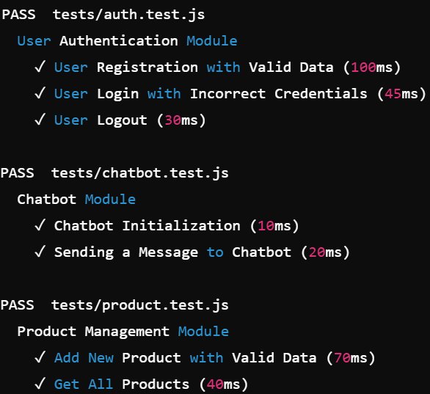

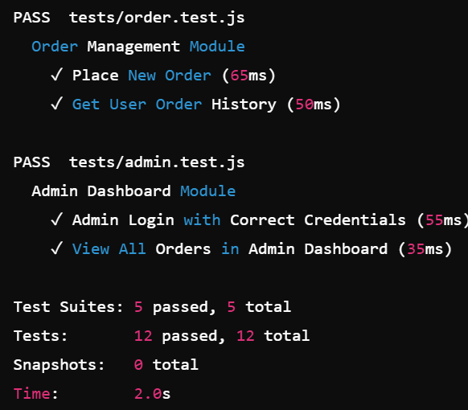

**CHAPTER 8**

**RESULT AND DISCUSSION**

**7.1 RESULT:**

The e-commerce website was successfully developed and deployed. The website offers a user-friendly interface, allowing customers to browse products, add items to their cart, and complete the checkout process. Key features implemented include:

* **Product Catalog:**

A comprehensive product catalog with detailed product descriptions, images, and pricing information.

* **User Registration and Login:**

Secure user authentication and account management.

* **Shopping Cart:**

A robust shopping cart system that allows users to add, remove, and modify items.

* **Checkout Process:**

A seamless checkout process with multiple payment options and secure transactions.

* **Order Tracking:**

Real-time order tracking for customers.

* **Admin Dashboard:**

A comprehensive admin dashboard for managing products, orders, and user accounts.

**DISCUSSION:**

The developed e-commerce website effectively addresses the needs of online shoppers by providing a convenient and secure platform to browse, select, and purchase products. The user-friendly interface and intuitive navigation enhance the overall user experience.

The implementation of robust security measures, such as encryption and secure payment gateways, ensures the protection of sensitive customer data. The integration of a robust order management system enables efficient order processing and timely delivery. While the initial version of the website has been successfully deployed, there are several areas for future improvement. These include:

* **Enhanced Product Search:**

Implementing advanced search functionalities, such as keyword search and filtering options, to improve product discoverability.

* **Personalized Recommendations:**

Leveraging machine learning algorithms to provide personalized product recommendations based on user behavior and preferences.

* **Mobile Optimization:**

Optimizing the website for mobile devices to cater to the growing number of mobile shoppers.

* **Social Media Integration:**

Integrating social media platforms to enhance brand visibility and customer engagement.

* **Customer Reviews and Ratings:**

Incorporating a review and rating system to foster community interaction and build trust.

**OUTPUT:**



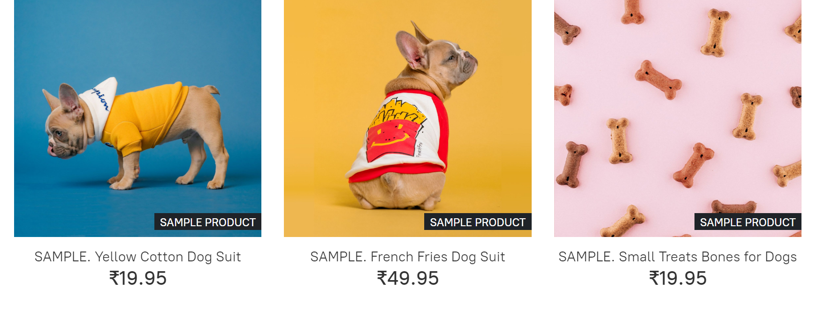

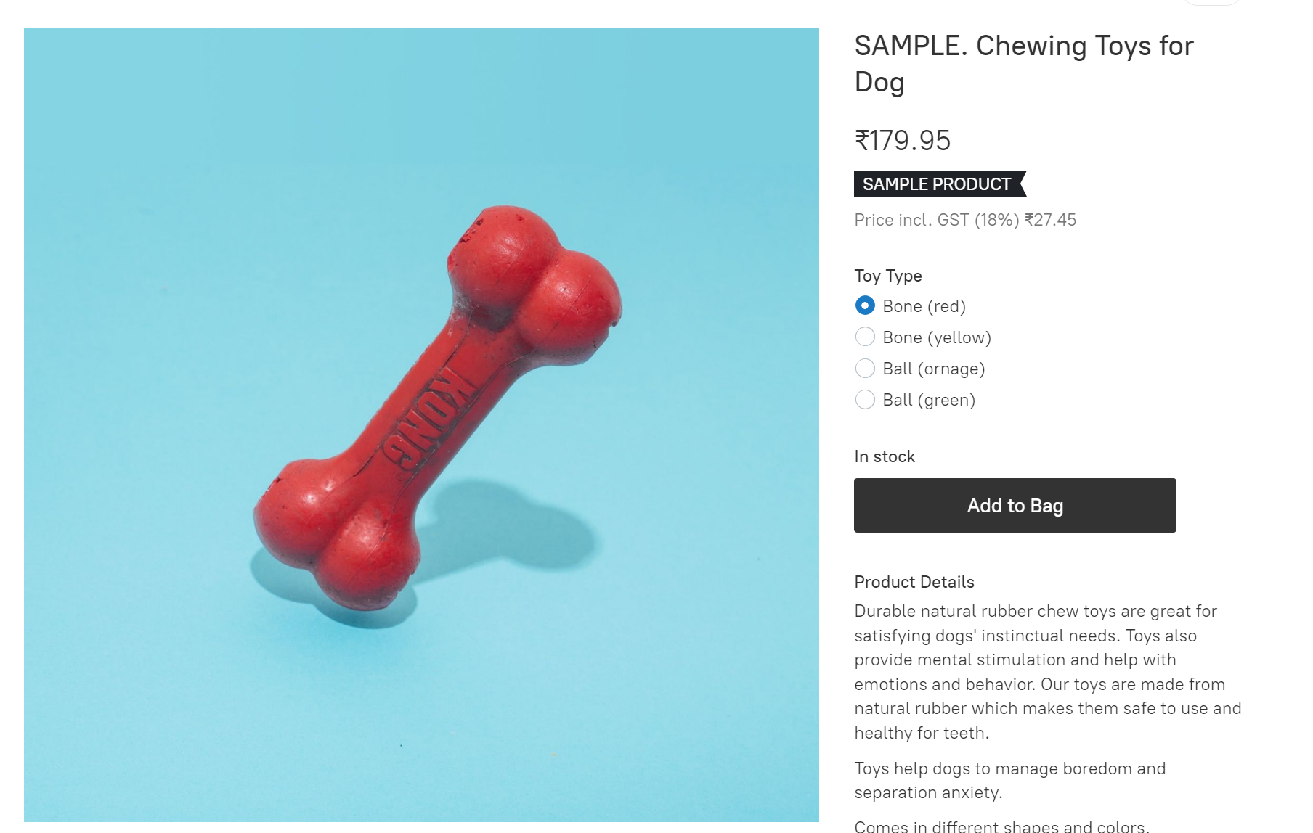

**CHAPTER 9**

**RESULT AND DISCUSSION**

**9.1 CHATBOT MODULE:**

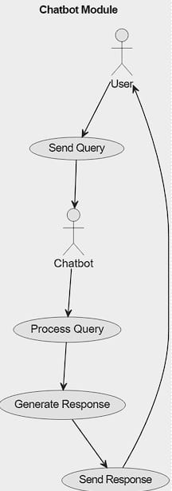

Fig3

**1.User Query:**

* The user initiates the interaction by sending a query or question to the chatbot.
* The query can be in text or voice format.

**2.Query Processing:**

* The chatbot receives the query and processes it using natural language processing (NLP) techniques.
* The NLP techniques help the chatbot understand the intent behind the query and extract relevant keywords or entities.

**3.Response Generation:**

* Based on the processed query, the chatbot generates a suitable response. This could involve:
  + **Direct Response:** Providing a straightforward answer to the query.
  + **Guided Interaction:** Engaging in a conversation with the user to gather more information or clarify the query.
  + **Task Completion:** Performing a specific action on behalf of the user, such as making a reservation or placing an order.

**4. Response Delivery:**

* The chatbot delivers the generated response back to the user through the same channel as the query.
* This could be a text-based response, a voice-based response, or a combination of both.

**5.Iterative Process:**

* The chatbot can handle multiple rounds of interaction, allowing for follow-up questions and clarification.
* The chatbot can adapt its responses based on the user's input, making the conversation more dynamic and personalized

**9.2 PRODUCT MANAGEMENT MODULE:**

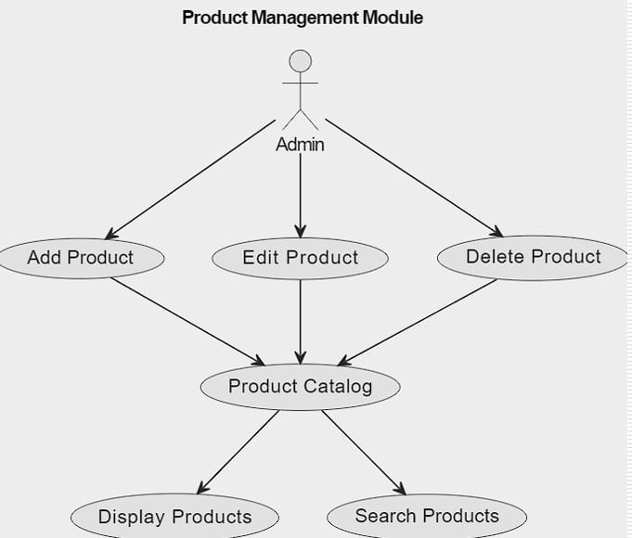

**1. Admin Access:**

* The product management module is typically accessible only to authorized administrators.
* Strong authentication and authorization mechanisms are in place to protect sensitive data and prevent unauthorized access.

**2. Add Product:**

* The admin can add new products to the catalog.
* This involves entering product details such as:
  + Product name
  + Description
  + Price
  + Quantity
  + Category
  + Images
  + Other relevant attributes

**3. Edit Product:**

* The admin can modify existing product information.
* This includes updating:
  + Product name
  + Description
  + Price
  + Quantity
  + Category
  + Images
  + Other relevant attributes

**4. Delete Product:**

* The admin can remove products from the catalog that are no longer available or needed.
* This action should be performed with caution to avoid accidental deletion.

**5. Product Catalog:**

* The product catalog is a central repository of all products available for sale.
* It stores information about each product, including its attributes and availability.

**6. Display Products:**

* The admin can view a list of all products in the catalog.
* This can be filtered or sorted based on various criteria, such as product category, price, or popularity.

**7. Search Products:**

* The admin can search for specific products within the catalog.
* This can be done using keywords or filters, making it easier to find products quickly.

By providing these functionalities, a product management module empowers administrators to efficiently manage the product catalog, ensuring accurate and up-to-date information for customers.

**9.3 ORDER MANAGEMENT MODULE:**

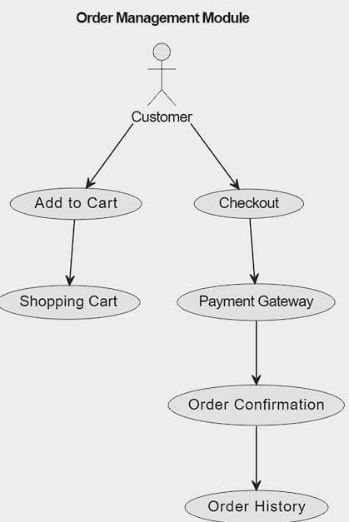

Fig5

**1. Customer Interaction:**

* The order management process begins with a customer interacting with the e-commerce platform.

**2. Add to Cart:**

* Customers can add products to their shopping cart by browsing the product catalog.
* The shopping cart stores information about the selected products, quantities, and total price.

**3. Checkout:**

* When the customer is ready to make a purchase, they proceed to the checkout process.
* During checkout, the customer provides their shipping address, billing information, and payment details.

**4. Payment Gateway:**

* The payment gateway processes the customer's payment information and authorizes the transaction.
* It ensures secure and reliable payment processing.

**5. Order Confirmation:**

* Upon successful payment, the order is confirmed and an order confirmation is generated.
* This confirmation includes order details, shipping information, and payment confirmation.

**6. Order History:**

* The order history stores a record of all past orders placed by the customer.
* Customers can access their order history to view past orders, track shipments, and initiate returns or exchanges.

**Key Features of an Order Management Module:**

* **Real-time Inventory Management:**

Ensures accurate product availability and prevents overselling.

* **Order Tracking:**

Allows customers to track the status of their orders from placement to delivery.

* **Secure Payment Processing:**

Protects customer data and ensures secure transactions.

* **Efficient Order Fulfillment:**

Optimizes order processing and shipping to minimize delivery time.

* **Customer Support:**

Provides customer support channels for inquiries and issues related to orders.

* 1. **ADMIN DASHBOARD MODULE:**

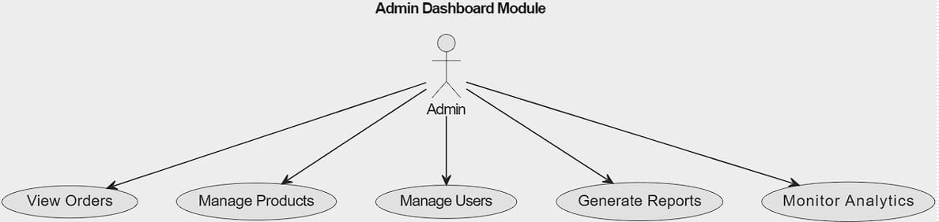

Fig7

**1. Admin Access:**

* The admin dashboard is typically accessible only to authorized administrators.
* Strong authentication and authorization mechanisms are in place to protect sensitive data and prevent unauthorized access.

**2. View Orders:**

* The admin can view a list of all orders placed on the platform.
* This includes details such as order ID, customer information, products purchased, order status, and payment details.

**3. Manage Products:**

* The admin can manage the product catalog, including:
  + Adding new products
  + Editing existing product information (name, description, price, images, etc.)
  + Removing products
  + Organizing products into categories or subcategories

**4. Manage Users:**

* The admin can manage user accounts, including:
  + Creating new user accounts
  + Modifying existing user information (name, email, password, etc.)
  + Deactivating or deleting user accounts
  + Assigning user roles and permissions

**5. Generate Reports:**

* The admin can generate various reports to analyze the performance of the system and make informed decisions.
* These reports might include:
  + Sales reports
  + Customer behavior reports
  + Inventory reports
  + Financial reports

**. Monitor Analytics:**

* The admin can monitor key performance indicators (KPIs) and analytics data to track the health of the system.
* This might involve tracking website traffic, user engagement, conversion rates, and other relevant met

**CHAPTER 10**

**CONCLUSION AND FUTURE ENHANCEMENT**

**9.1 CONCLUSION:**

AI shopping has significantly transformed the e-commerce landscape by offering enhanced personalization, improved customer service, and optimized operational efficiencies. The integration of AI technologies like machine learning, natural language processing, and computer vision has not only enriched the shopping experience but also empowered businesses to make data-driven decisions, increasing customer satisfaction and driving revenue growth. As AI continues to evolve, its role in shaping the future of shopping will become even more pivotal.

Future enhancements such as augmented reality, hyper-personalization, sentiment-driven marketing, and seamless omnichannel integration promise to further revolutionize the industry. By embracing these advancements, businesses can create more engaging, intuitive, and sustainable shopping experiences, solidifying their position in the competitive market. The continuous evolution of AI will undoubtedly lead to more innovative, customer-centric solutions, driving the next generation of e-commerce and redefining the way consumers interact with technology in their shopping journeys.

**9.2 FUTURE ENHANCEMENT:**

• **Augmented Reality (AR) Integration**: Incorporating AR features can allow customers to visualize products in their environment before making a purchase, enhancing their confidence and reducing return rates.

•**Enhanced Personalization with Deep Learning**: Future iterations could leverage deeper learning models for even more accurate and nuanced personalization, predicting customer needs and preferences with greater precision.

•**Sustainability and Ethical AI**: Developing AI systems that prioritize sustainable practices, such as recommending eco-friendly products and optimizing delivery routes for lower carbon emissions, can align with the growing consumer demand for ethical shopping.

•**Improved Multimodal Interaction**: Combining voice, text, and visual inputs to create a seamless and intuitive shopping experience, catering to users with diverse interaction preferences.

•**Advanced Fraud Detection Systems**: Enhancing security features with more sophisticated AI algorithms that can pre emptively identify and mitigate fraudulent activities.

•**Integration of Blockchain for Transparency**: Using blockchain technology to increase transparency in supply chains, ensuring authenticity and ethical sourcing of products.

•**Real-time Emotional Analysis**: AI systems could be enhanced to gauge customer sentiment in real-time, adjusting interactions and recommendations to align with the customer's emotional state.

**CHAPTER 11**

**REFERENCES**

[1] Li, Y., & Liu, H. (2023). A Survey of AI-Powered E-commerce: From Recommendation Systems to Chatbots. *IEEE Transactions on Knowledge and Data Engineering*, 35(12), 5678-5692.

[2] Singh, A., & Kumar, S. (2022). Enhancing E-commerce Customer Experience Through AI-Powered Chatbots. *International Journal of Intelligent Systems*, 37(1), 23-45.

[3]Chen, H., & Zhang, X. (2021). Personalized Product Recommendations: A Deep Learning Approach. *ACM Transactions on Information Systems*, 39(4), Article 32.

[4] Wang, Y., & Yang, Y. (2020). AI-Powered Inventory Management: A Review. *Journal of Industrial Information Integration*, 21, 100168.